**Get Started**

This guide is intended for people developing applications for themselves or their organization. If you are developing an application that will be used by other businesses, see the Get Started for Solution Partners (<https://developers.facebook.com/docs/whatsapp/cloud-api/get-started-for-solution-partners>) doc or the Get Started for Tech Providers (<https://developers.facebook.com/docs/whatsapp/cloud-api/get-started-for-tech-providers>) doc.

**Before You Start**

You will need:

* A Meta developer account — If you don’t have one, you can [create a Meta developer account here](https://developers.facebook.com/async/registration) ( https:// developers.facebook.com/ ).
* A business app — If you don't have one, you can [learn to create a business app here](https://developers.facebook.com/docs/development/create-an-app/) ([https://developers.facebook.com/docs/development/create-an-app](:/developers.facebook.com/docs/development/create-an-app/)/) . If you don't see an option to create a business app, select **Other** > **Next** > **Business**.

**Step 1: Add The WhatSapp Product To Your App**

At this point, if you created a new app, you’ll be prompted to **Add products to your app**. Scroll down, and under **WhatsApp**, select **Set up**. Otherwise, select your app from the **My Apps** screen, and you can follow the same instructions again to add WhatsApp to your app.

If you have a Meta Business Account (MBA), you will be prompted to attach it when adding the WhatsApp product to your app. If you don’t have an MBA, you’ll be taken through some prompts that will help you create one. Once your MBA is attached to your application, you’ll be ready to start testing.

Adding the WhatsApp product to your app does a few things for you:

* Prompts you to create a Meta Business Account if you don’t have one.
* Creates a test WhatsApp Business Account for you, automatically. This account has limitations and should be used for testing and development purposes since you don't pay for messages.
* Creates a test business phone number associated with your WhatsApp Business Account. With this number, you can send free messages to up to 5 recipient phone numbers.
* Creates a set of pre-approved message templates.
* Click on create app

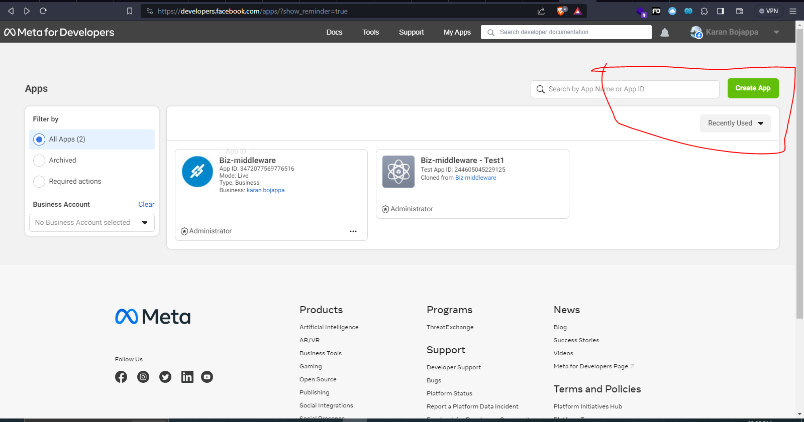

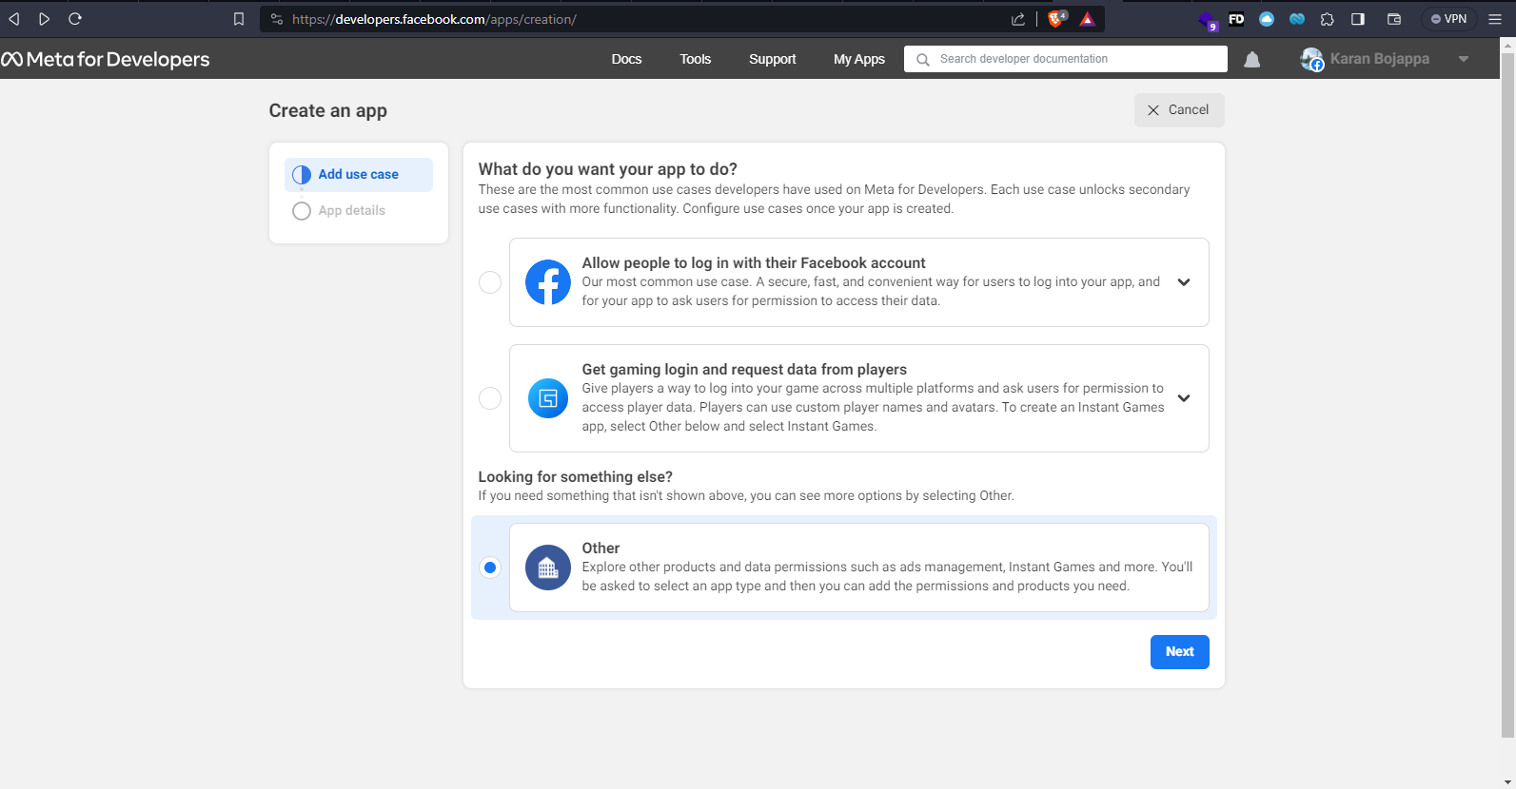

Select last option and click next

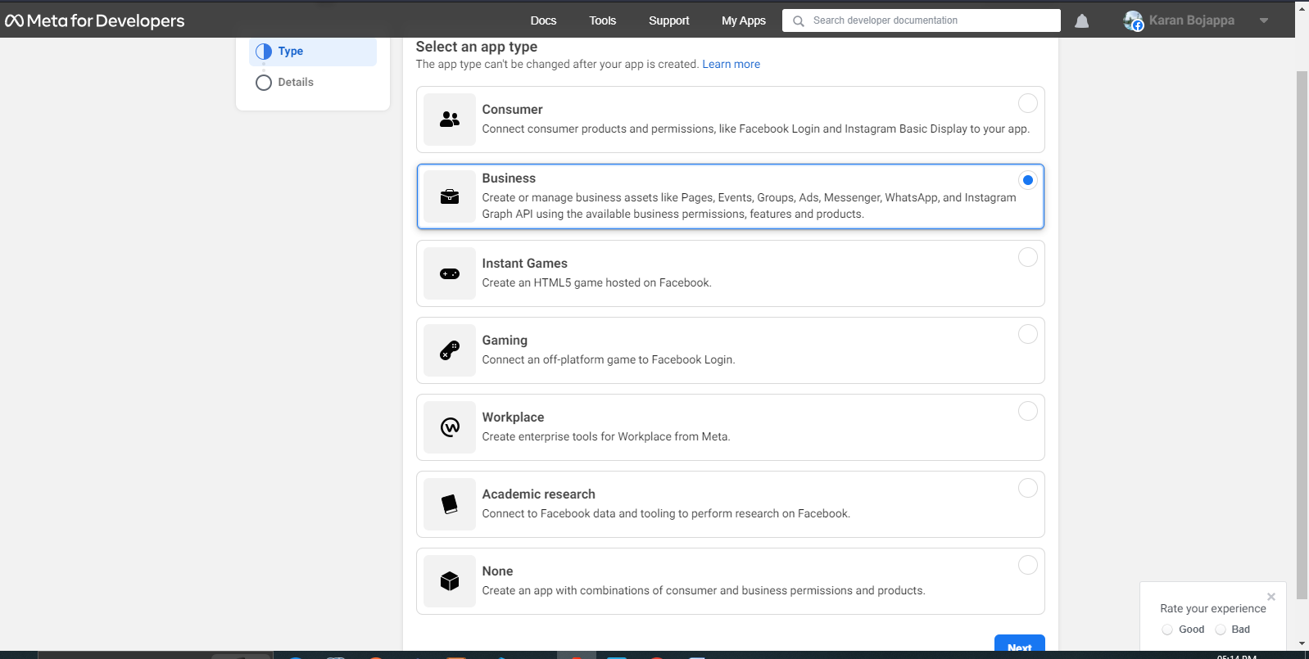

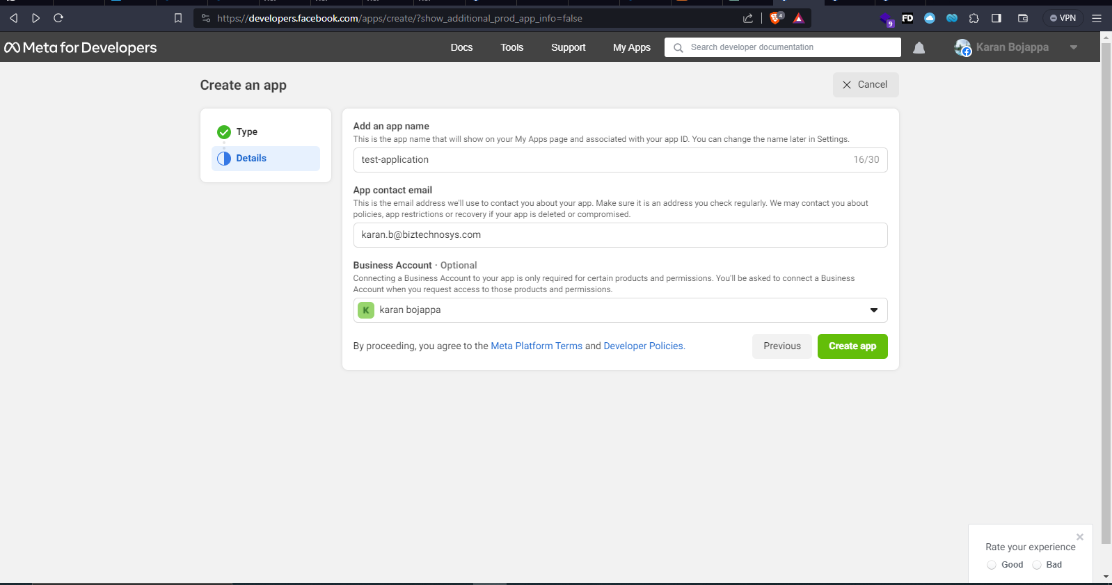

Click on create app

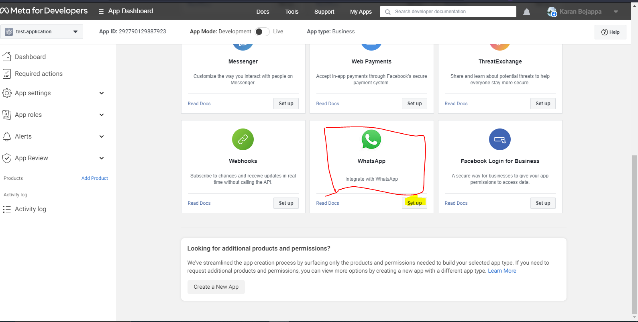

Click on setup

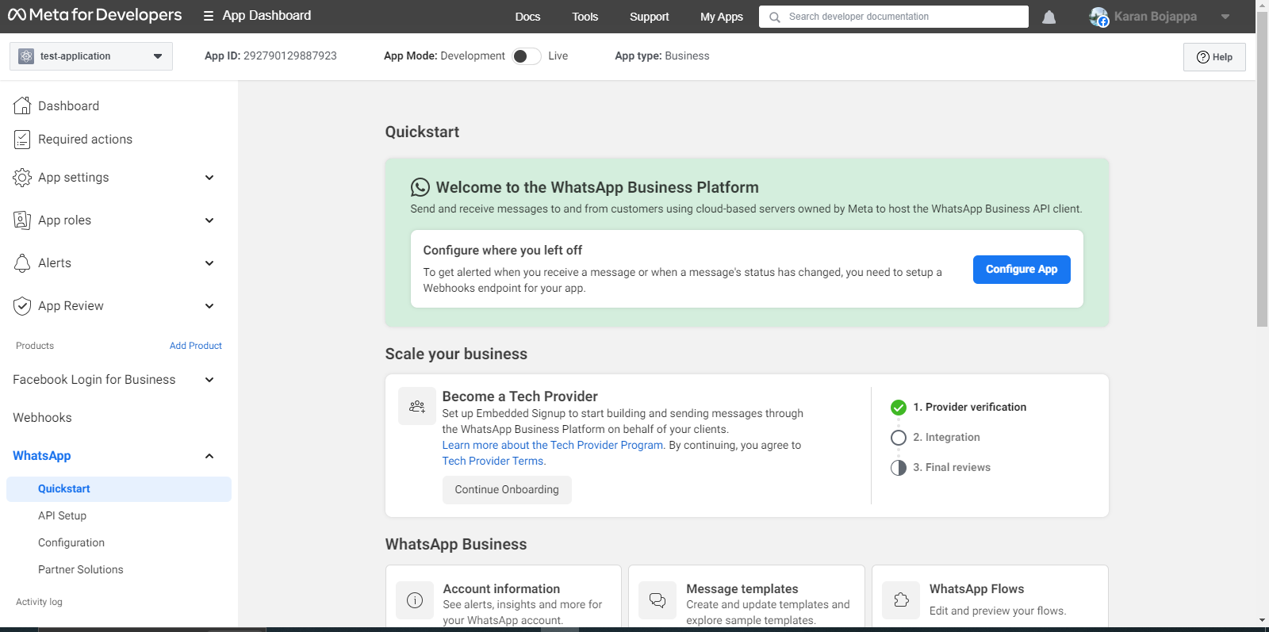

Now click on configure Api

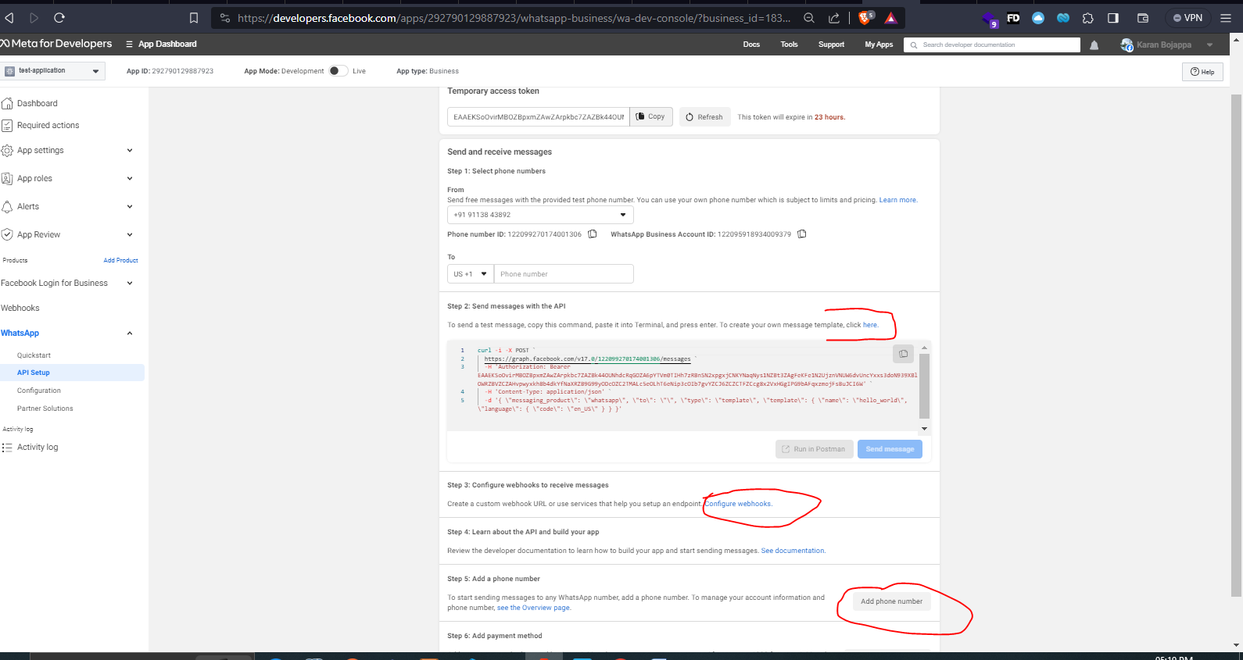

Now we have the api setuped

By clicking run in postman we can fork the api to our local and start using it   
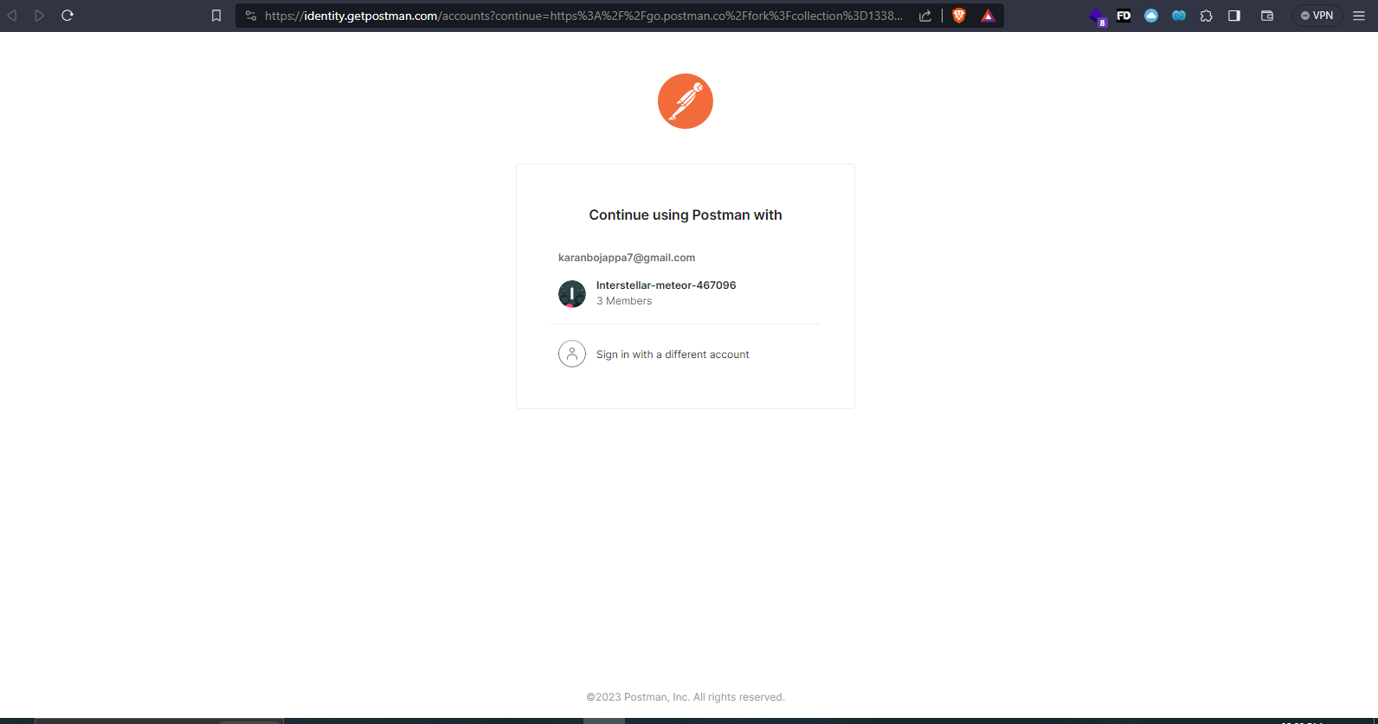

**Step 2: Add a Recipient Number**

Add a valid WhatsApp number where you can send test messages.

In the left-hand menu of the App Dashboard, navigate to **WhatsApp** > **API Setup**. Under **Send and receive messages**, select the **To** field and choose **Manage phone number list**.

You can add any valid WhatsApp number as a recipient. The recipient number will receive a confirmation code in WhatsApp that can be used to verify the number.

Once you verify the recipient number, it should now be selected in the **To** field. Repeat this process if you’d like to add another recipient, up to 5 in total.

**Step 3: Send a Test Message**

Send the pre-approved hello_world template message to your chosen recipient number.

In the **WhatsApp** > **API Setup** panel:

1. Ensure your test business phone number is selected in the **From** field.
2. Ensure you have the recipient phone number you would like to message selected in the **To** field. If you have multiple numbers added, you can send multiple messages at once.
3. In the **Send messages with the API** panel, click the **Send message** button.

Alternatively, you can copy the cURL command, then paste it into a new terminal window and run it.

Notice that the code indicates you are sending a template message (”type”:”template”) and identifying a specific template to use (”name”:”hello_world”).

**Step 4: Clone Our Sample App and Configure Webhooks**

With webhooks, you can receive real-time HTTP notifications of changes to specific objects. In WhatsApp, webhooks can notify you of many events in your app, like message delivery and read notifications, and even account changes.

Add a callback URL in order to see the contents of webhooks. Follow our [Sample Callback URL for Webhooks Testing guide](https://developers.facebook.com/docs/whatsapp/sample-app-endpoints) (<https://developers.facebook.com/docs/whatsapp/sample-app-endpoints>) to clone our sample app, which accepts webhooks notifications and displays their JSON payloads on-screen.

Once your webhook is set up, resend the template message and then reply back to it. You should see 4 separate webhook notifications: The message send, delivered, and read notifications, and the incoming message contents. Nice work!

**Step 5: (Optional) Add a Real Business Number**

With your test business number and test WhatsApp business account, you can begin to develop your application. When you use these test assets, you don’t pay to send messages as you work to develop your app.

Once you are ready to start sending messages to your customers, you can add a real business phone number in the **API Setup** panel and create a real WhatsApp Business Account.

By following below Facebook meta documentation, we can get permanent token,

[https://developers.facebook.com/docs/whatsapp/business-management-api/get-started#system-users](https://developers.facebook.com/docs/whatsapp/business-management-api/get-started%23system-users)

Permanent token is achieved after registering the new number, verification of the company and by adding payment methods , the process takes around 7 days or above.